NATIONAL ENROLMENT SERVICE (NES)
The NES is the single source of truth for all national enrolment data. It provides the capability to support Practices by assisting identification and enrolment assessments. NES integrates with the PMS via a secure web-based service, and links directly to the Ministry of Health national identity and enrolment databases.
WHAT HAS CHANGED AFTER ACTIVATION (MyPractice)
CHANGE #1: “Check NHI”
You now have a “Check NHI” option to check the information that NHI has on your patient.
CHANGE #2: Blue column in the middle to update information
Once you click on “Check NHI” you will be able to compare and update information to your local register (left) or to the NHI record (right). The BLUE column will allow this.
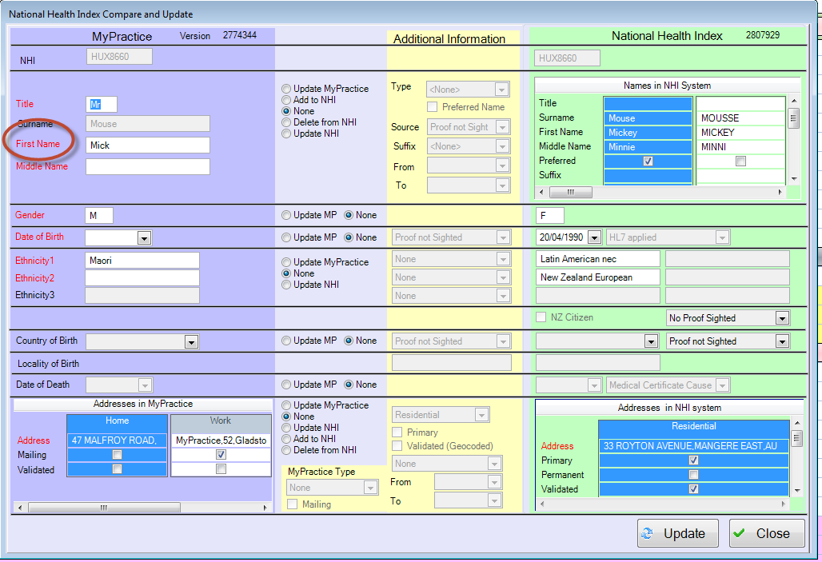
CHANGE #3: E-enrolment entry in Schemes
This will also include any High User Health Cards or Community Services Cards which the patient has.
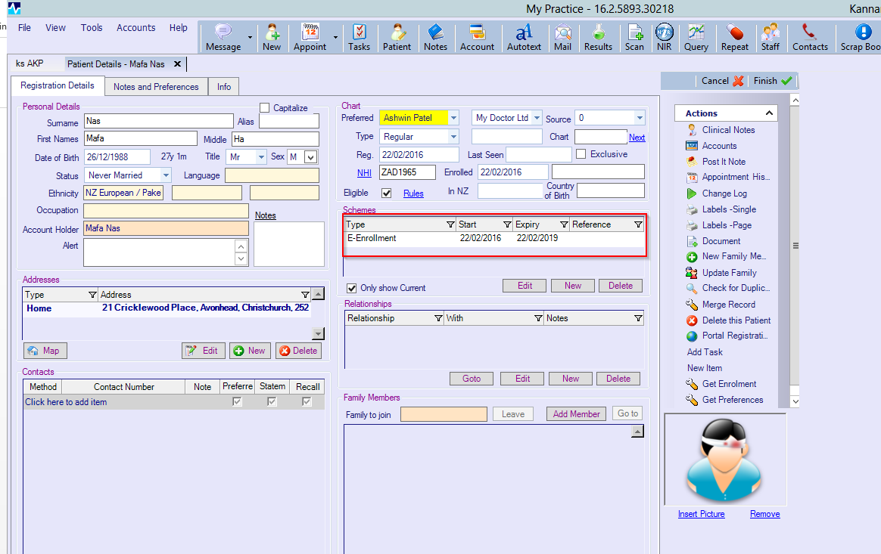
CHANGE #4: Qualified encounter date and expiry date updated on NES when user selects “Leave” for patient.
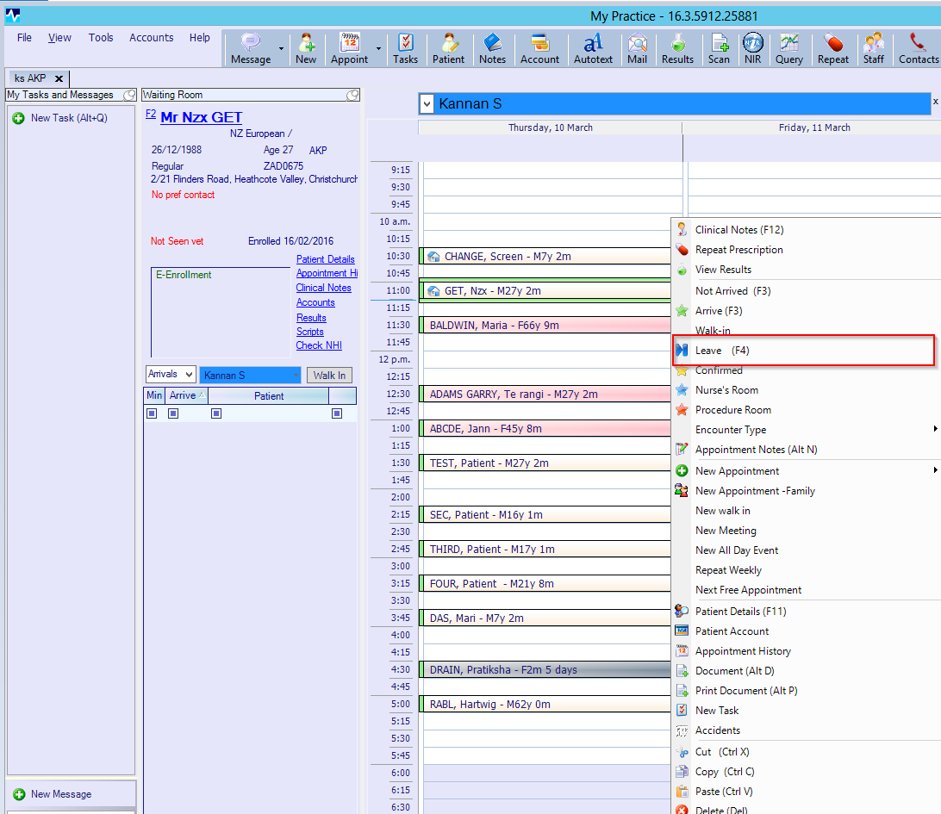

NES - IMPORTANT THINGS:
- Always confirm the patient’s information when they come into the practice and validate NES.
- The information on your PMS system is more up to date than the information on NHI, so you need to update NHI with the information you have – i.e. the NHI information is most likely to be out of date so UPDATE.
- Correct all the information on NHI. REMEMBER that all the information that goes into the NES has to be correct.
- Don’t guess any information – all information has to be confirmed by the patient.

